In configuration manager right click the desired project and open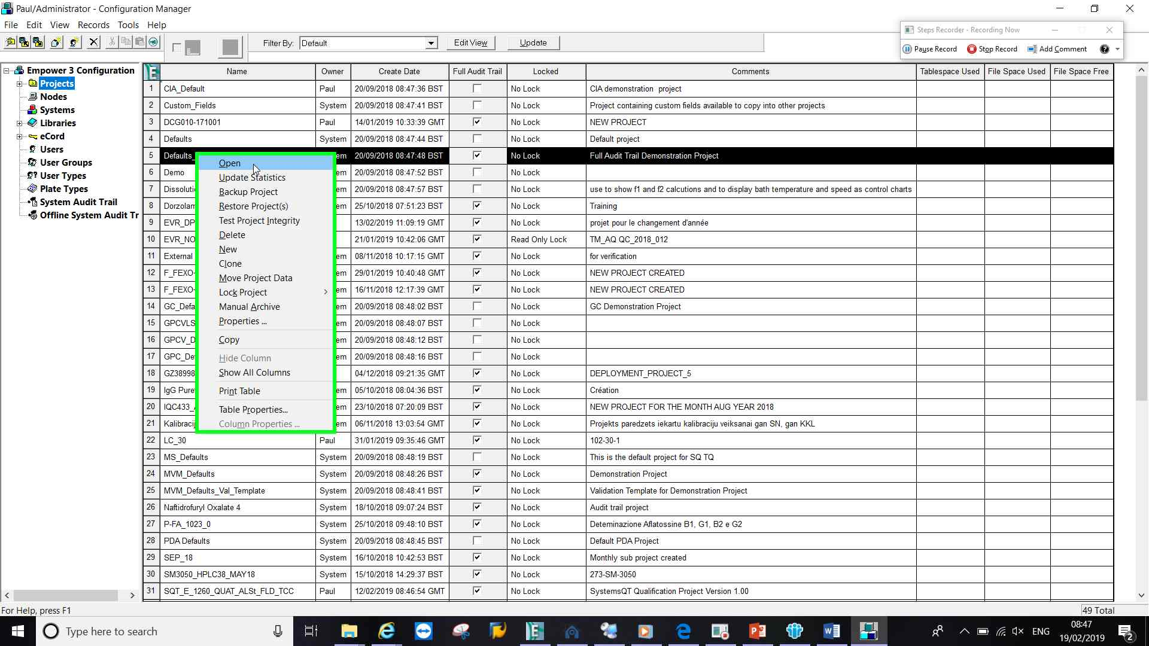
Click the Audit trails tab and select the ‘Filter By’ drop down box.
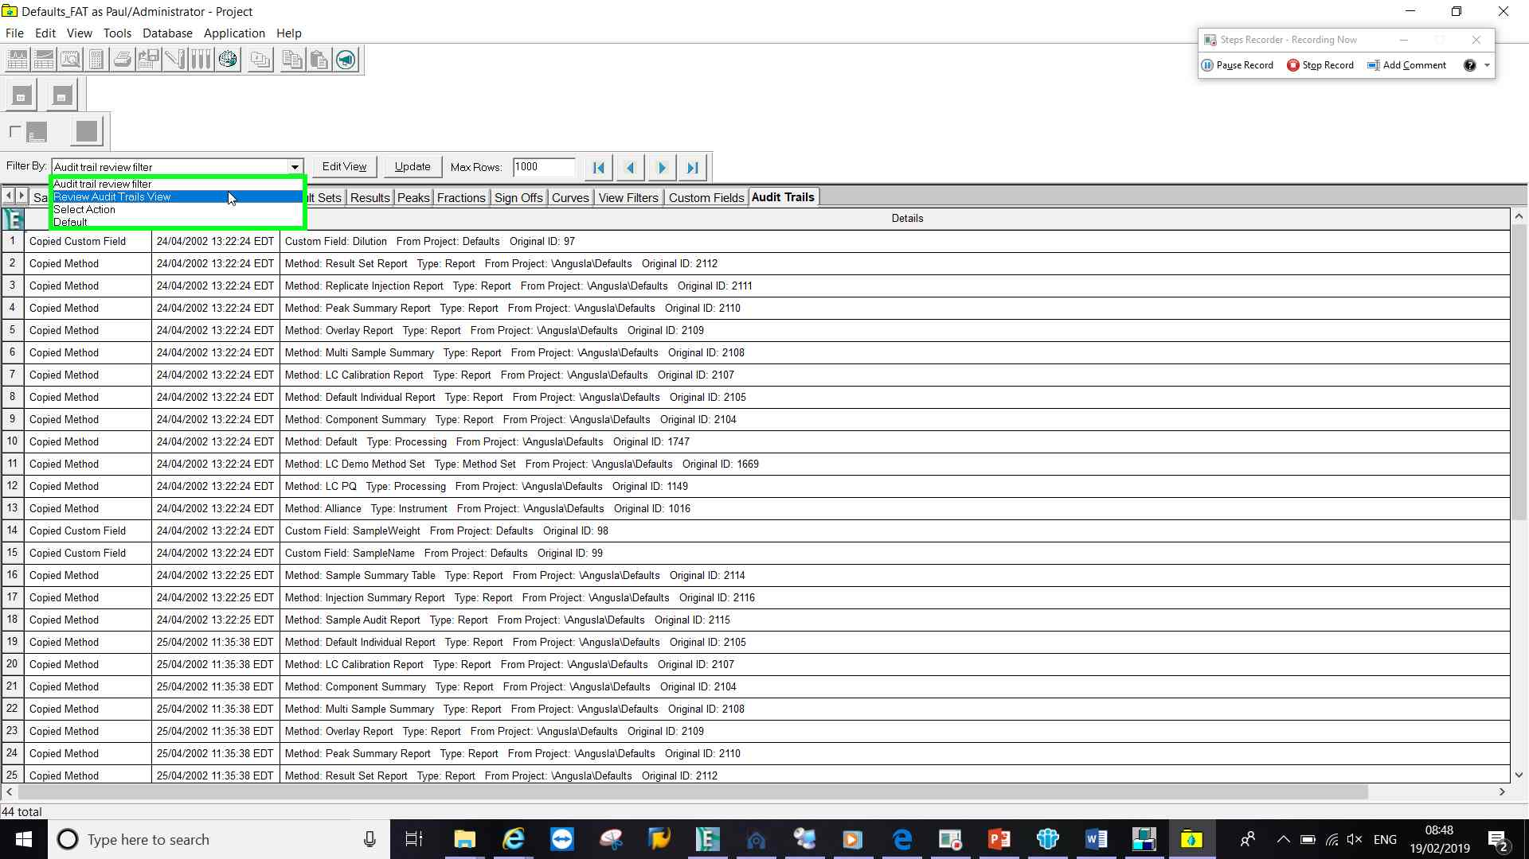
Select a pre-configured or previously created view filter.
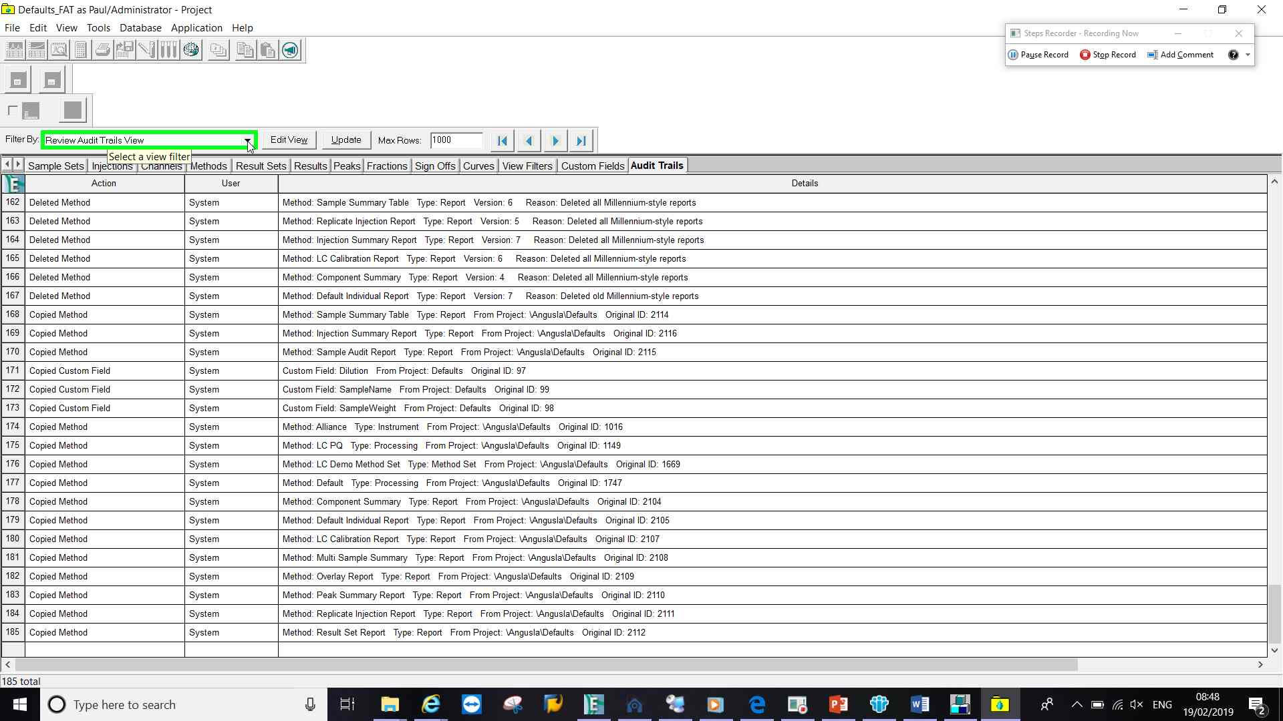
If no pre-configured or previously created view filters click ‘EDIT VIEW’
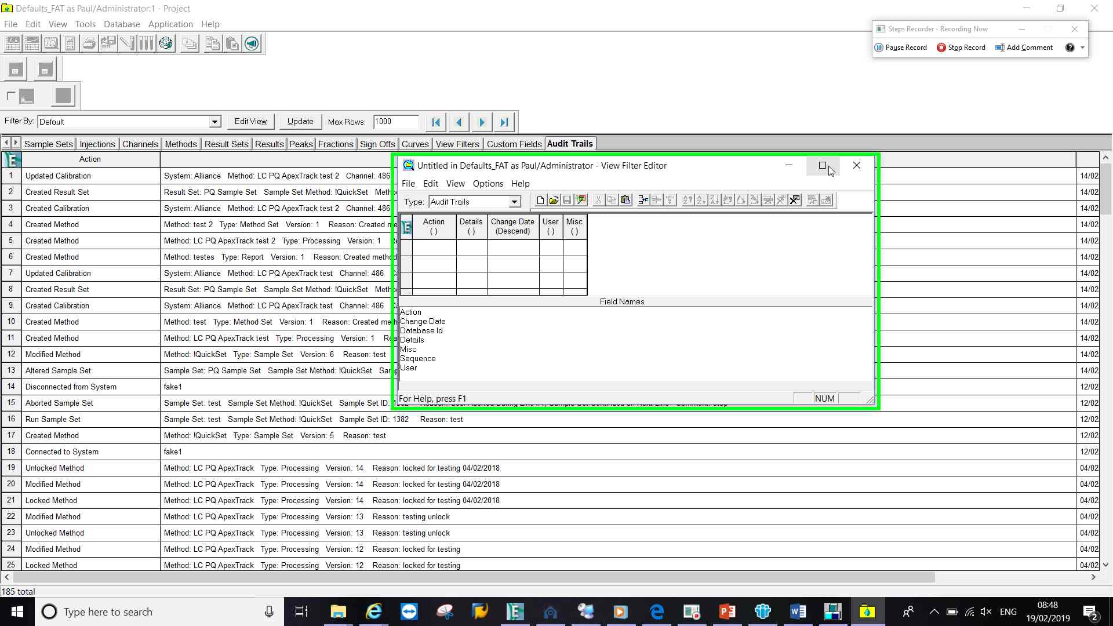
Click on the view filter wizard
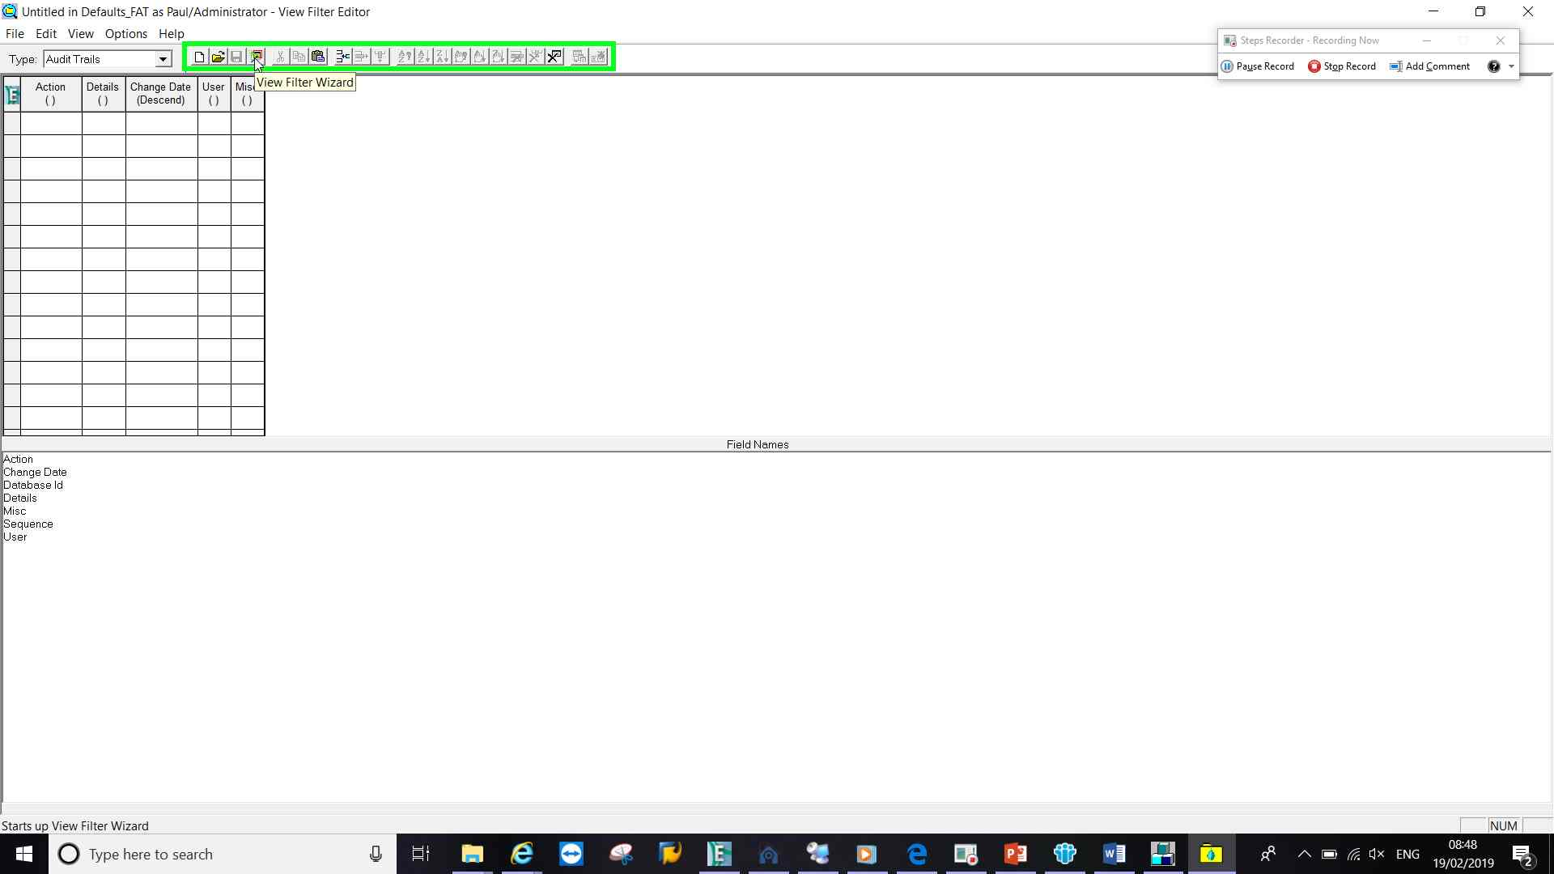
Select the fields required and click NEXT
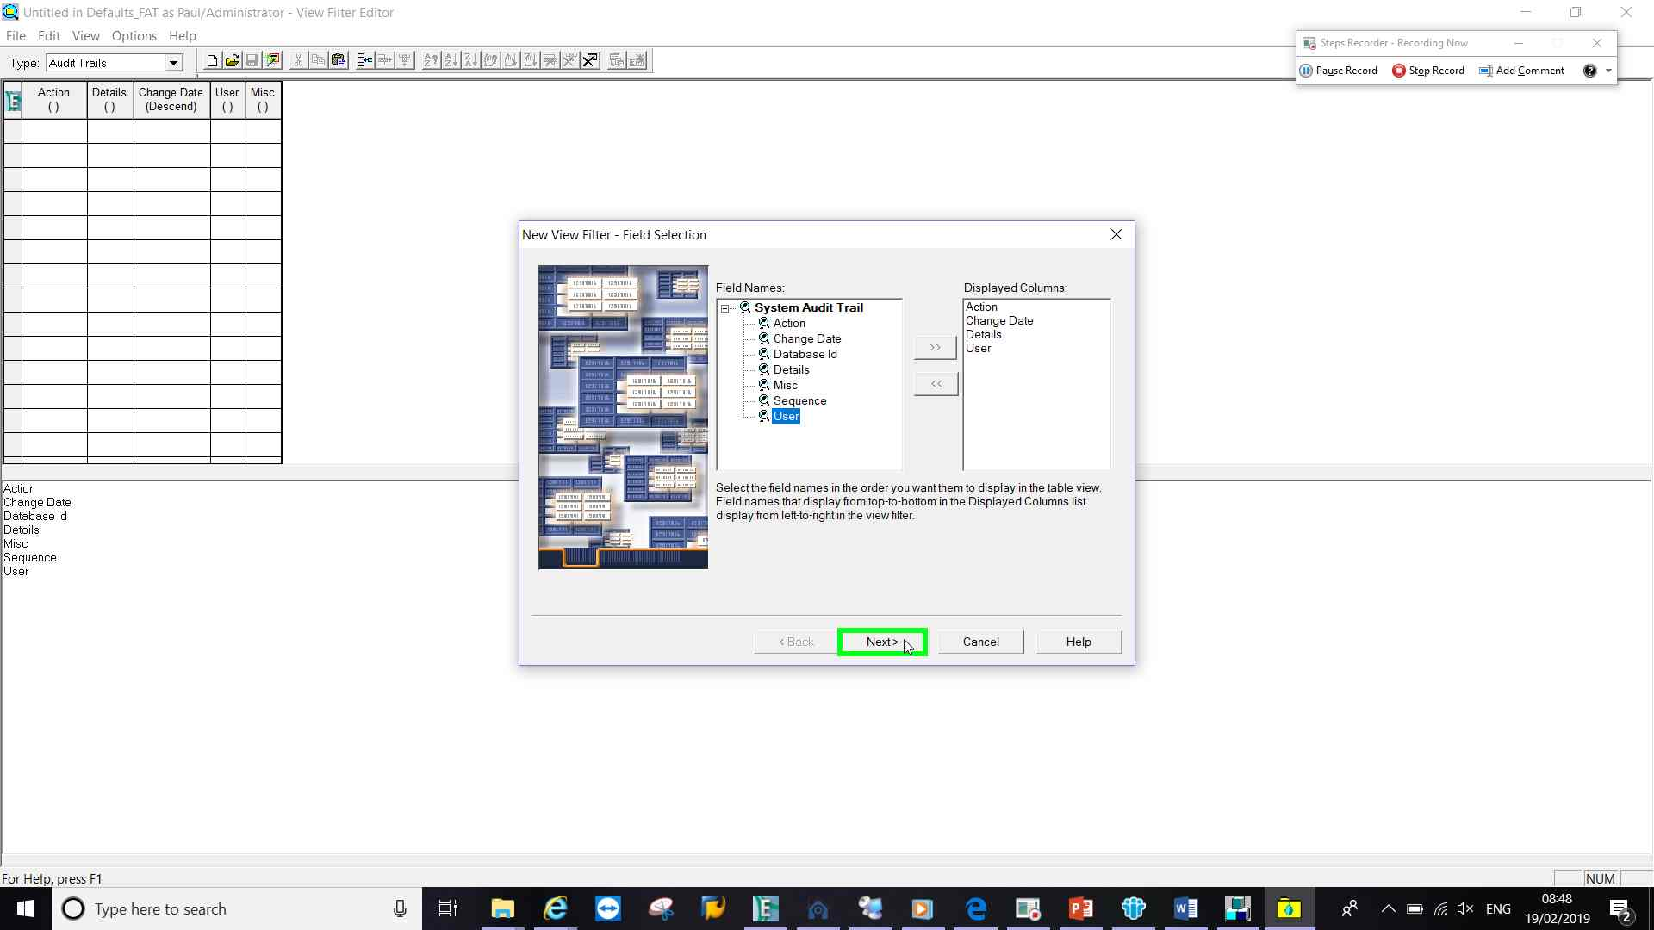

Create conditions as required.
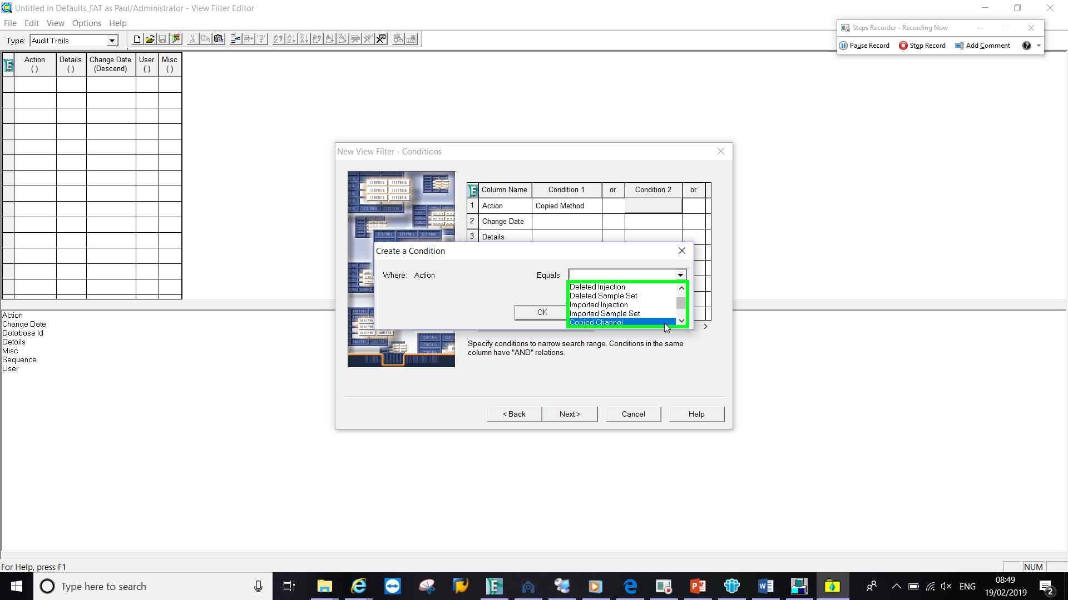
Select sorting options
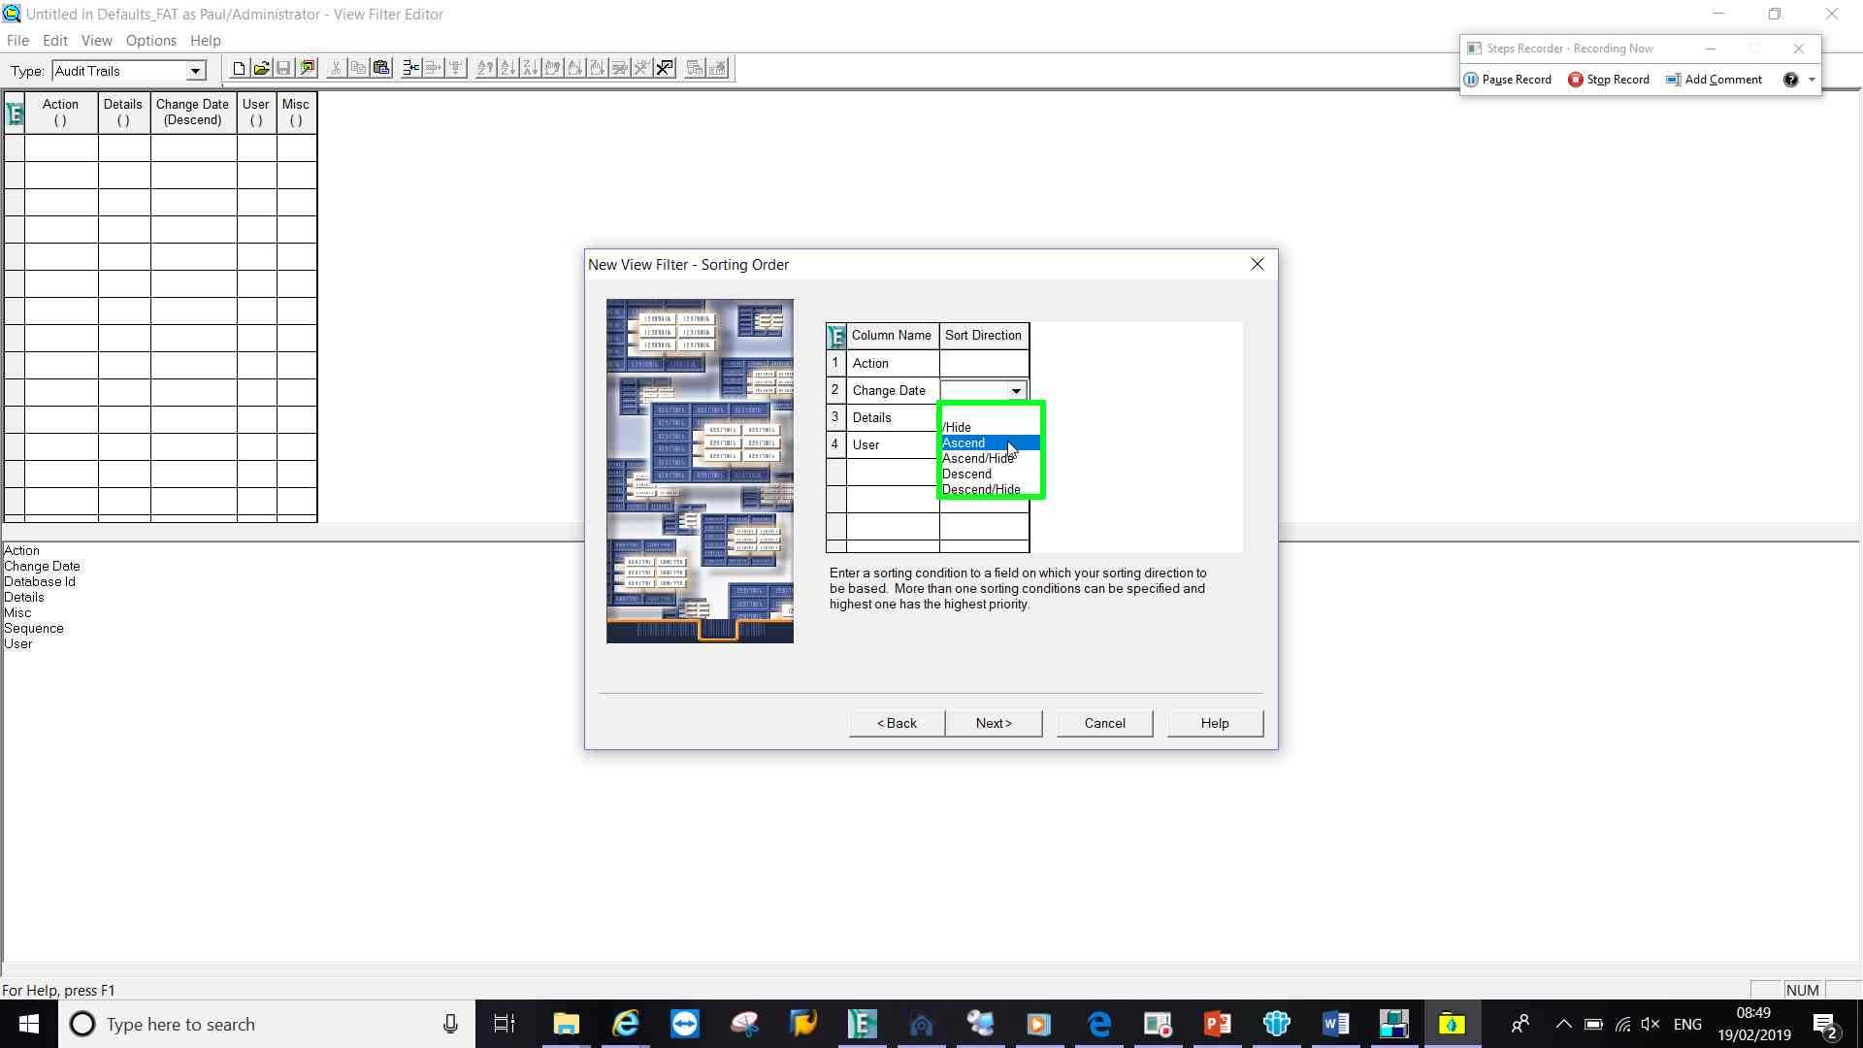
Give it a name, make it public, specify interfaces and finish.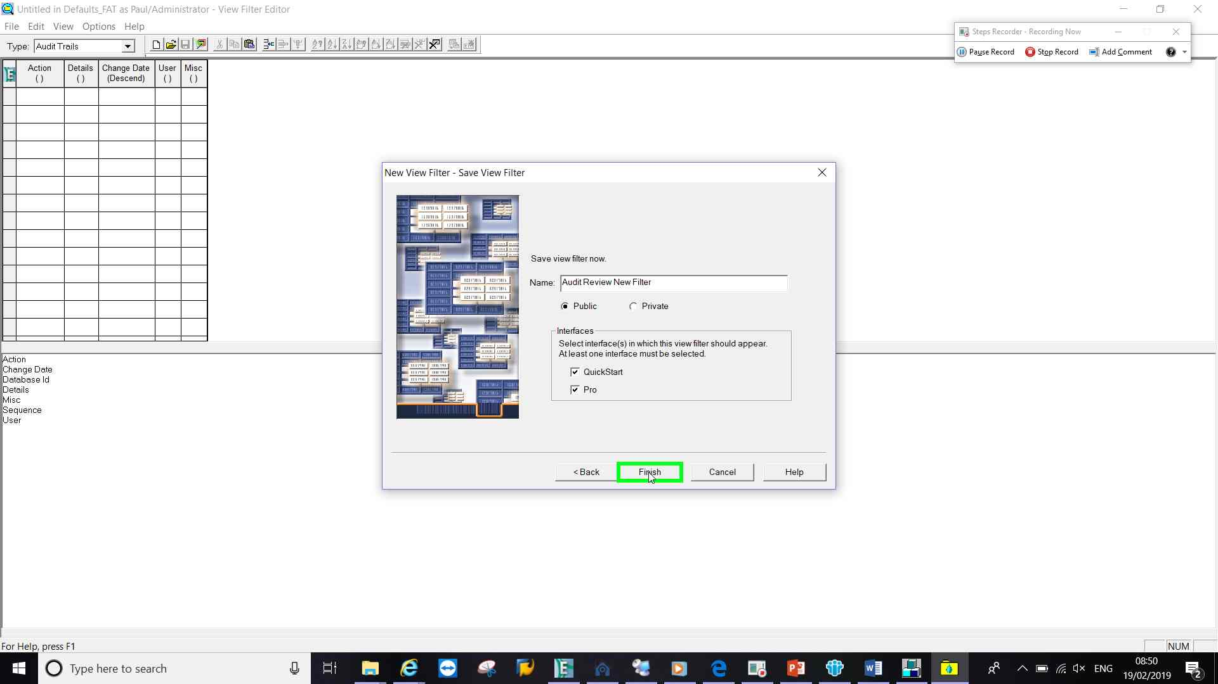

Close the Wizard window
The new view filter is now available in the ‘filter by’ drop down box.
