Procedure to Modify a Report to Correct Text Overlap

- In Empower Project window, right click on a result set or a result and choose Preview/Publisher.
- Switch the report from Preview to Edit mode by clicking on the Close button on the top menu.
- Click on the Header icon on the top menu if it is not already set as the default page.
- Right click on the Acquisition Information report group (block) and choose Ungroup.

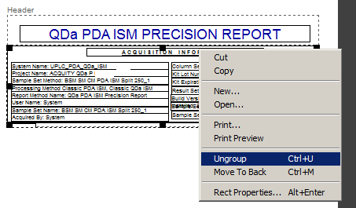

- Pull down the bottom border of the group.

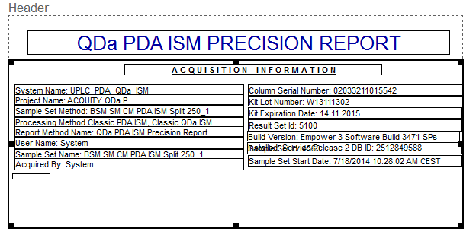

- If the boxes inside the group block cannot be activated, then right click on the block and choose Move to Back.
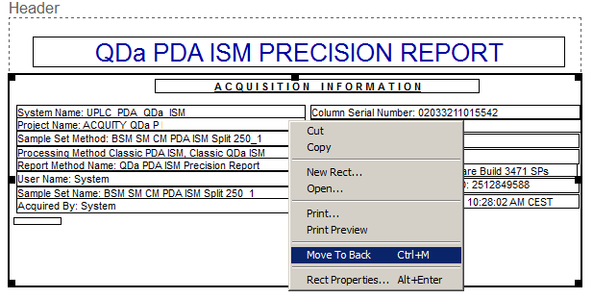
- Highlight the last text box from the bottom and move it down,
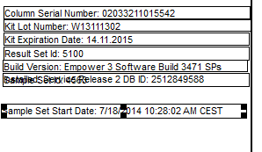
- Similarly move the next text box from the bottom so that the full text for “Build Version” field is displayed.
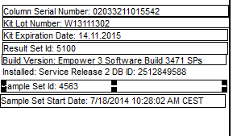

- Draw a box around the whole text block to highlight all the text boxes.
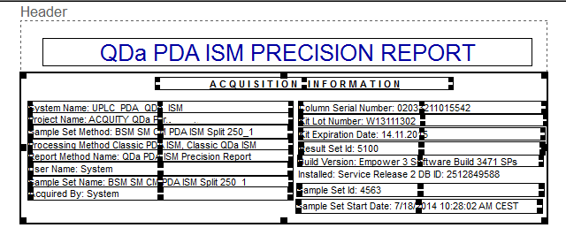
Go to Edit>Group to regroup the Acquisition Information block.
Then go to File>Save to save the modified report. Example Audit Trail comment: “Repositioned text fields within the Acquisition Information group in the Header to avoid text overlap.”

