Procedure to reset Oracle and UNIFI services so you can login
If this message is displayed during the UNIFI login
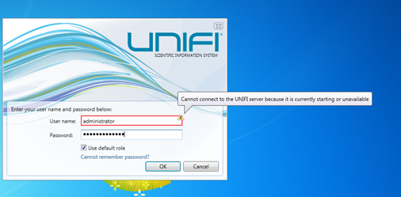

Go to Start , then type in services. Double click the Services item under Programs
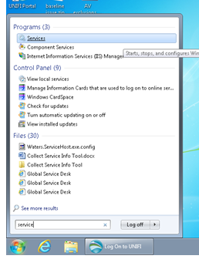
Once the Services program group opens, scroll down the list until you see OracleServiceUNIFI
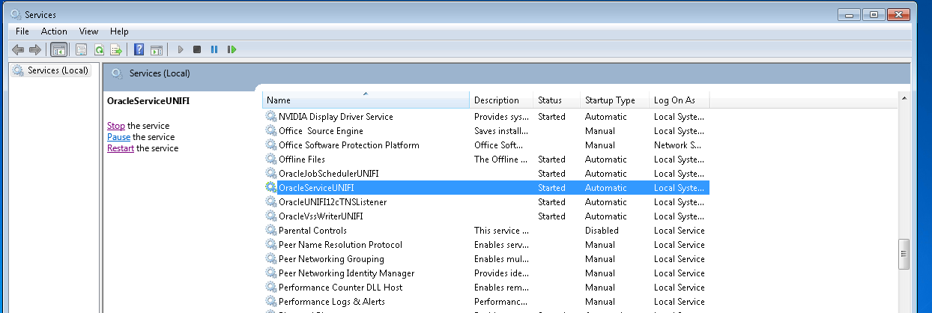
Right click this item the select Stop, once the service is stopped, right click again and select Start
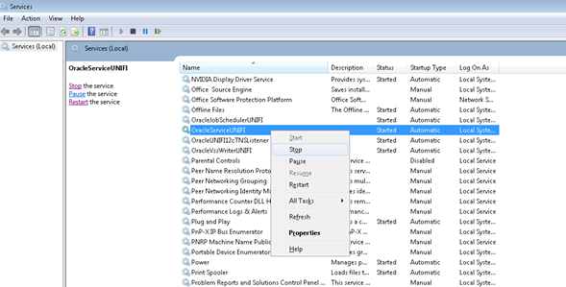
When this services is Started, will take a couple minutes, scroll down to the Waters Service Host, this may be Stopped or have no status info displayed. Right click on the line item then select Start.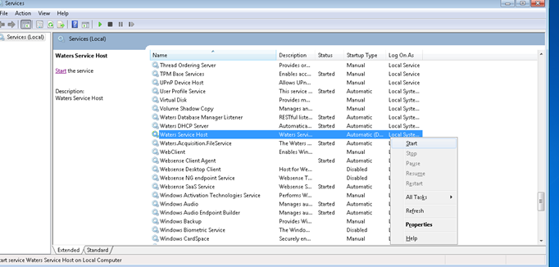
After a few second the status will display Started, wait a few minutes then check the Process from Task Manager to ensure all 8 Waters.ServiceHosts.exe are listed. You should be OK to login now.
